**Analog/Digital Converter**

Driver Project 4



ENEL 511 - Embedded System Interfacing

**Lab B02 Group 10 Members:**

Dan Tran - 30050533

Justin Nguyen - 30042258

Nathan Tham - 30046119

**Professor:**

Jaspreet Kaur

**State Diagram**

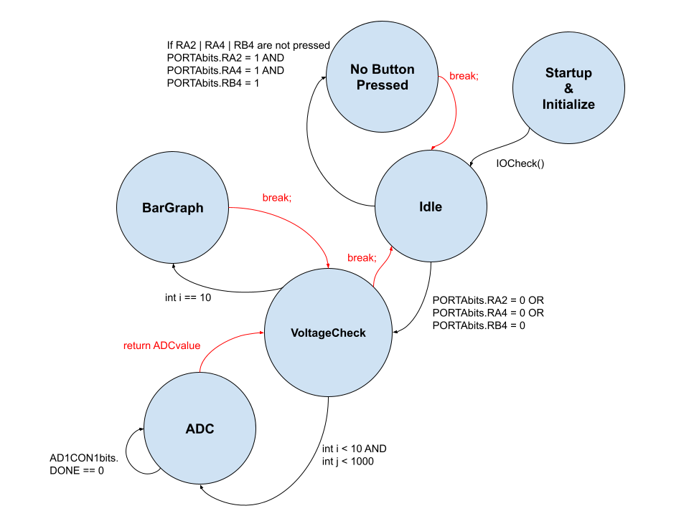

**Workload**

1. Justin Nguyen
   1. Primary logic development
   2. Record video
2. Dan Tran
   1. Drew the state diagram
   2. Helped develop code
3. Nathan Tham
   1. Primary microcontroller coder
   2. Helped developed logic